Product Specification
Personal GPS tracking device

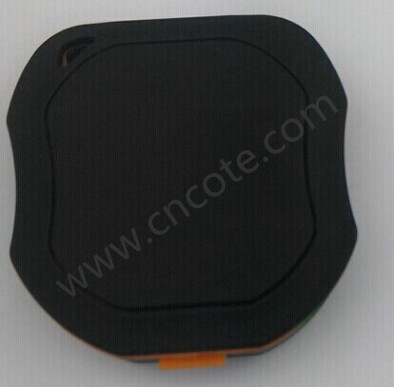

CE-P9

1. Hardware Introduction
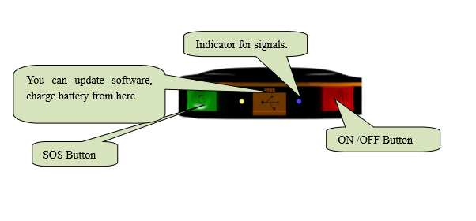

Main Feature:
1. Online web platform, the historical and current location can be checked.
2. E-fence function.
3. Hijack alarm,9 SOS numbers can be preset.
4. Remote voice monitoring.
5. Low battery alarm.
6. Inlayed 3D accelerator，moving and static state, energy smart.
7. Change the time interval of uploading automatically according to the speed.
8. Admin checks the altitude and longitude and location information by texting.
9. A-GPS solutions，shorter locating time，higher precision.
10. Long Duration battery up to 48 hours fully working ( test under updating per 30 seconds).
11. Sleep model ,800MAH battery, can work 3 days .

