Product Specification

CE-02
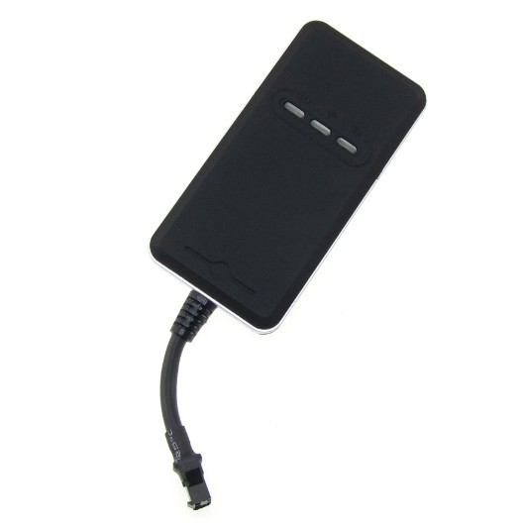

Name: CE-02
Vehicle GPS tracker
Main Feature:
GPS + GSM + GPRS wireless positioning system
Quad band GMS frequency for global use
Built-in high sensitive GPS chipset
Built-in GSM & GPS antenna
Real-time tracking
Auto start when power connected
Built-in watchdog function, auto reboot when accident happens
Built-in switch power supply, with wide voltage input
Built-in acceleration sensor, intelligent power saving and static drifts resisting
Installing method: covert / open
Three LED indicators: GPS - Blue; GSM - Green; Power - Red
Check location via platform service

Product Specifications:

Specifications
Weight | 53g
Dimensions | 86.7 ( L) X 44.0 (W) X 13.7 (H) mm
Working voltage/current | 9-36vDC / 25mA
Operation temperature | -25°C - 60°C
Operation humidity | 5% - 95% RH
LED indicator | Three LED indicators: GPS-blue; GSM-green; Power-red
GSM frequency | 850/ 900/ 1800/ 1900 MHz
GPRS | Class12, TCP/ IP build in GSM Module
GPS | MT3326
Frequency | L1,1575.42MHz C/A code
GPS antenna | Built-in high gain ceramic patch antenna
GPS Channels | 20
Tracking sensitivity | -159dBm
Acquisition sensitivity | -144dBm
Locating time cost | Hot start: <2 sec(open sky)
Locating time cost | Warm start: <15 sec
Locating time cost | Cold start: <38 sec(open sky)
Certifications | CE, ROHS

